o

**TECHNOLOGY & INFORMATION SYSTEM (SECP1513)**

**DESIGN THINKING REPORT**

**(CLOUD COMPUTING)**

**FACULTY OF COMPUTING**

| Lecturer | Dr. Aryati Binti Bakri |
| --- | --- |
| Section | 02 |
| Group | 08 |
| Group member | 1. Ahmad Adib Zikri Bin A.Mazlam (A23CS0205) |
| 2. Iman Abadi Bin Mohd Nizwan (A23CS0084) |
| 3. Muhammad Naim Bin Abdullah (A23CS0134) |
| 4. Muhammad Mukhritz Al Iman Bin Mohd Raffi (A23CS0250) |
| 5. Muhammad Afiq Danial Bin Rozaidie (A23CS0117) |

**TABLE OF CONTENTS**

Table of Contents…………………………………………………………………………………2

Introduction……………………………………………………………………………………….3

Detailed Step and Description…………………………………………………………………….4

Detailed Description (Problem Statement, Solution, Teamworking)..............................................7

Design Thinking Points…………………………………………………………………………...8

Design Thinking Evidence………………………………………………………………………..9

Reflection (Iman Abadi)................................................................................................................12

Reflection (Muhammad Naim)......................................................................................................13

Reflection (Muhammad Mukhritz)................................................................................................14

Reflection (Ahmad Adib)..............................................................................................................15

Reflection (Muhammad Afiq Danial)...........................................................................................16

Task Distribution………………………………………………………………………………...17

# **INTRODUCTION**

Design thinking is an important process which can help the user more understand their needs, make an assumption, define their problems and create innovative solutions to make a prototype and test it. Design thinking also contains 5 phases which are Empathy, Define, Ideate, Prototyping and lastly a Test. It is a useful process if we want to identify and deal with a problem in order to create the most effective and innovative solution. In this modern era, design thinking is the key to achieve success in almost every organisation and company. Design thinking is just a tool to solve some problem but it is a new way to create a whole new person who has a “thinking outside the box” mindset.

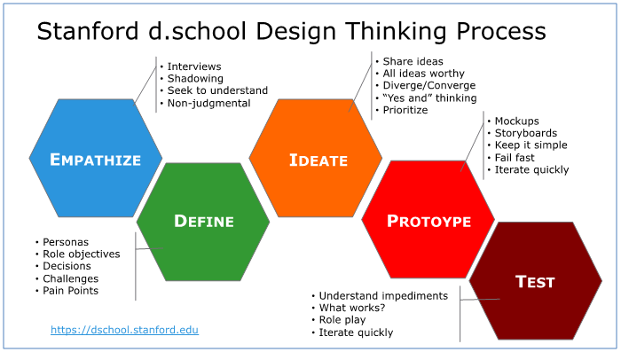

# **DETAILED STEP AND DESCRIPTION**

1. Empathy

* Empathy means the ability to share someone else's feelings or experiences by imagining what it would be like to be in that person's situation.

Through empathy, we are able to put ourselves in their shoes and feel what the user is feeling about a problem, circumstance and situation they might be in. So that is why we interviewed several people who are knowledgeable about cloud computing in the UTM Faculty Computing area. By doing this, we might be able to learn more deeply about cloud computing and might as well identify what is the problem that has been occurring when using some of the cloud services.

# (*Some of our member interviewed the lecturer to gather information about cloud computing*)

2. Define

* Define is the second phase of design thinking, where we analyse all the responses from our interview to define the problem statement that the user has been experiencing using cloud services. We have been discussing and brainstorming our ideas to list all the possible problems on cloud computing. Some of these problems include cost on using cloud services and latency or network.

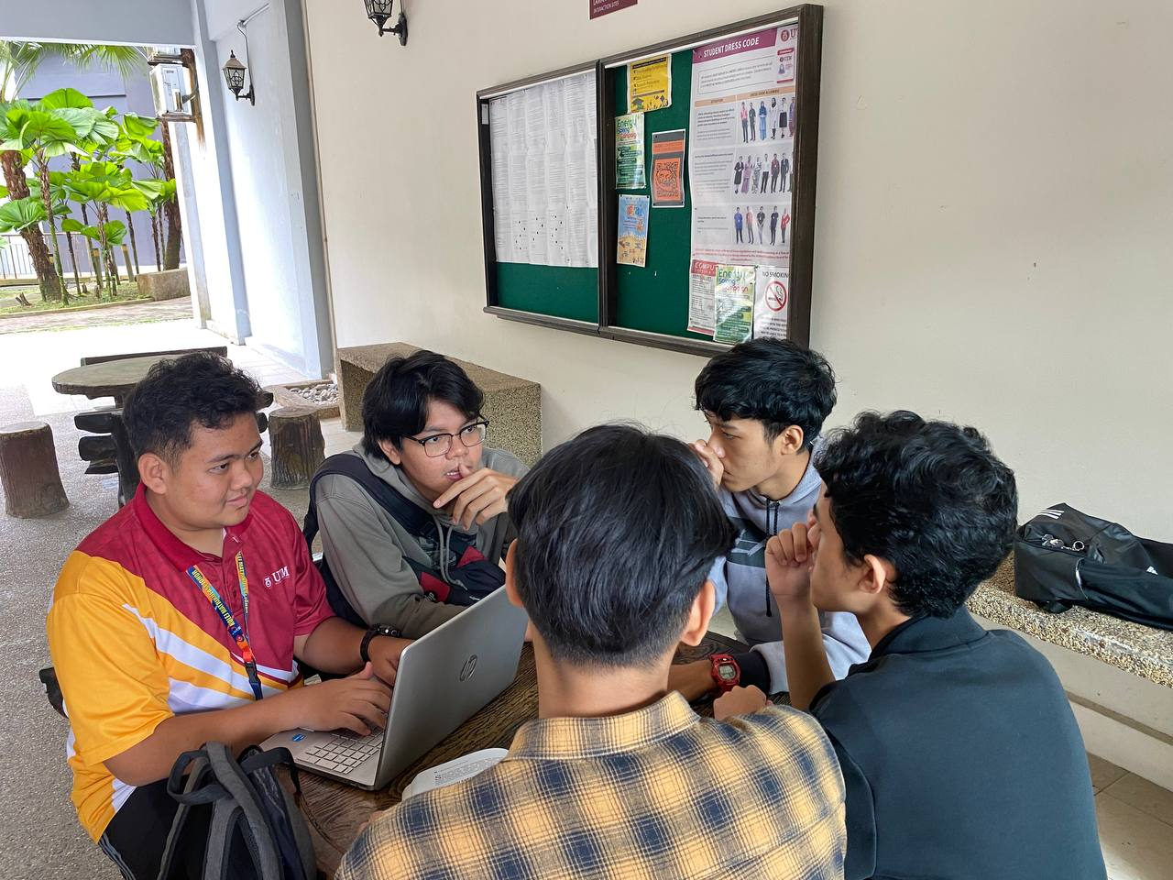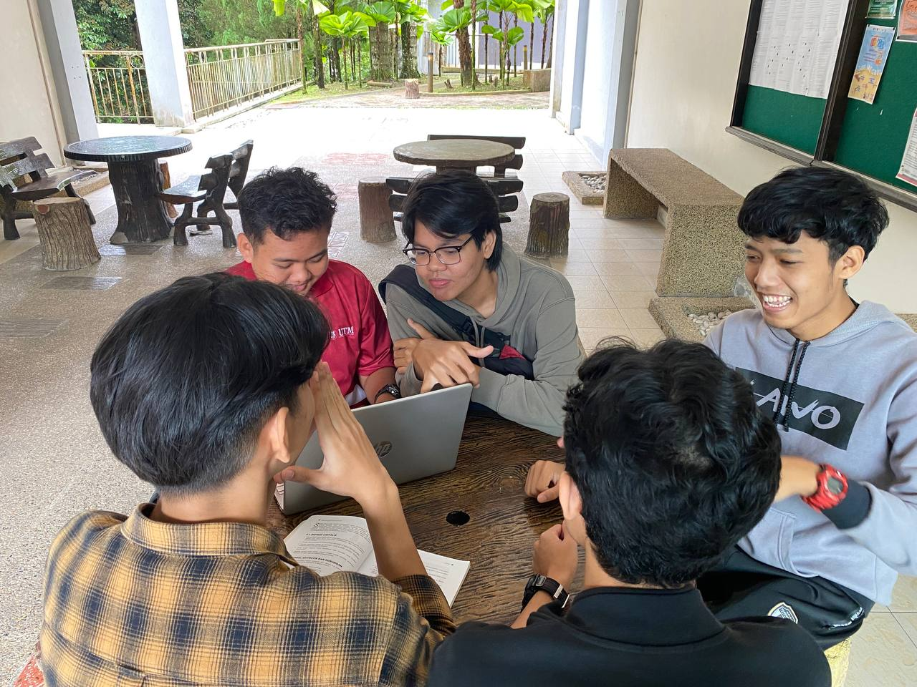

3. Ideate

* The next phase that is related to define phase which is ideate. To put it more simply, ideate is a solution to the problems that are happening like in this case is a cloud service. Based on our problems identified, we were doing some research ideas-sharing on how to solve these problems with an efficient and the best solution. Our priority to this solution is to keep it simple and easy to use. We also need to look up different perspectives while searching for solutions.

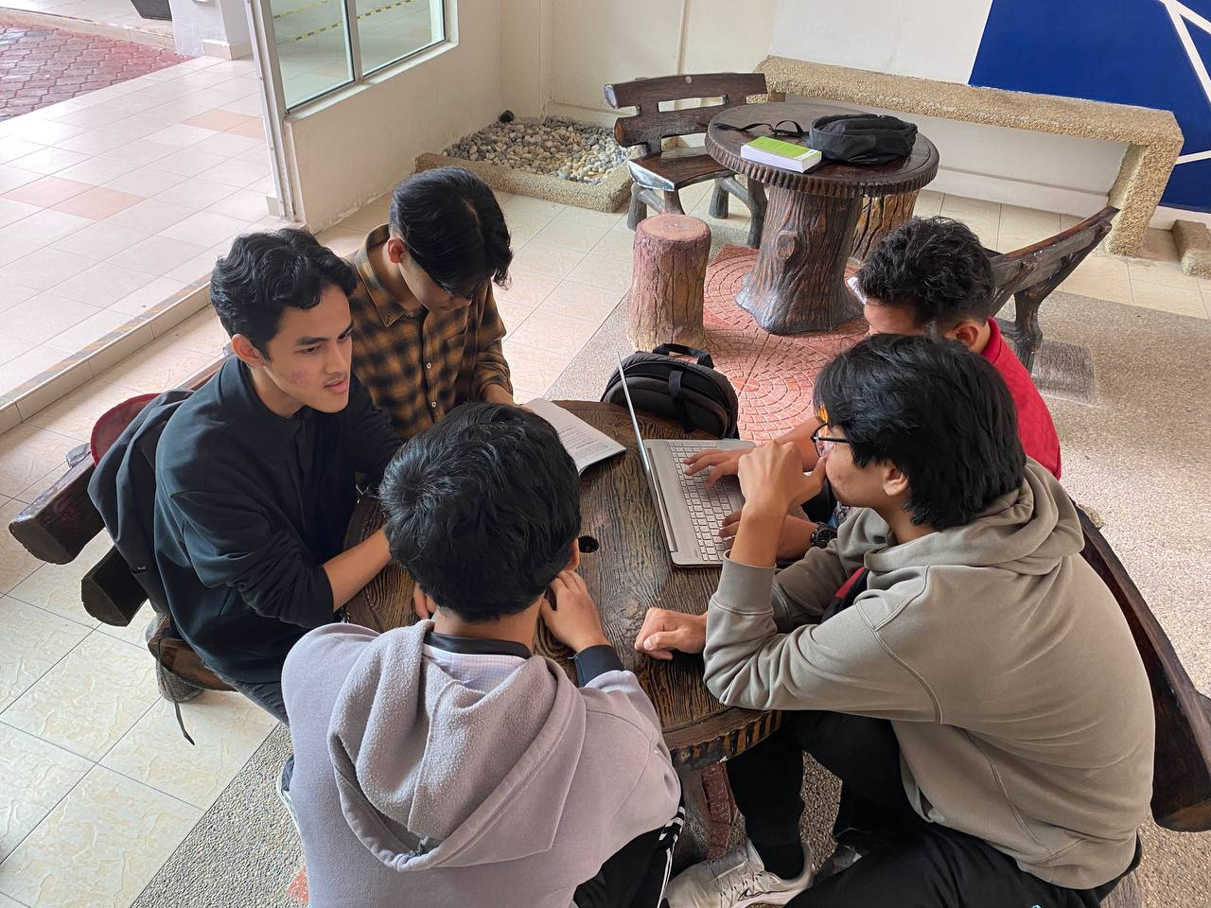

4. Prototype

* In this phase which is the prototype phase. Prototype is a product built to test ideas and changes until it resembles the final product. After we conclude all our solutions and then create a simple mockup just by using some paper and cardboard. We also make sure that the mockup fully meets the requirements to solve the problem. We also need to ensure that the message that we present is verified and understood by all the customers.

5. Test

* Last but not least, the test phase which helps product, design, and development teams evaluate their concepts and prototypes for a solution. This phase is to finalise whether this product actually meets the customer requirements or not. After we receive feedback from some of our customers, let's say that if some of them are unsatisfied with our product, we have to ask for some suggestions that might help us to fix it immediately.

# **DETAILED DESCRIPTION (PROBLEM STATEMENT, SOLUTION AND TEAM WORKING)**

# The problem that we obtained from the interview is the financial cost of public computing. Most cloud computing uses the pay-as-you-go method strictly using resources that are involved. The challenges arise when choosing plans that suit their needs. To find a plan that suits them, they are forced to try multiple plans to find one that meets their requirements which leads to unnecessary spending. Another problem is the unpredictable costs of cloud computing. Cloud computing is scalable; thus, an increase in resource scaling may be made aware by the user until the monthly bill is due. This results in unpredictable and varying costs.

# After we made a clear and defined problem, we brainstormed to find the best possible solution to this problem. Since our problem is difficulty in deciding on a suitable plant and unpredictable costs, we decided to implement a system that utilises artificial intelligence (AI) that monitors the user’s usage behaviour during the trial period. After that, it will then analyse the data and provide data visualisation. This helps the user understand their usage habits eliminating the need for them to figure out the service that they might use and vice versa. From the data, the system will also suggest to them the best plan for them to proceed with offering customization as well. If there are any new products being implemented in the future, the system will alert the user of the new cost. By doing this, it will prevent unexpected expenses in the future.

# The teamwork throughout this assignment has been positive. Although we had some disagreements during our discussion, all of us were open to hearing other opinions and suggestions to find the best possible outcome. After we were all settled with the solution, we divided our tasks to every member. All the members carried out their tasks immaculately. Members assigned to a task asked other members to give their input on the result they had produced to find out things for improvement. All members made progress on their tasks to be done on time.

# 

# **DESIGN THINKING ASSESSMENT POINT**

# 

# **AT THE END OF THE PROJECT**

# At the end of the project, reflections were made to verify the results and outcomes met up to standards with our initial intention, problem statement and solutions

# **DURING THE TRANSITION BETWEEN DESIGN THINKING PHASES**

# Empathise

# Since our project is about cloud computing, we decided to interview lecturers that have knowledge of cloud computing and someone who is a novice user of cloud computing service. In the interview, the lecturers expressed the problems they had with cloud computing which were the unpredictable cost of cloud computing.

# Define

# In this phase, we analyse the problem we obtained from the empathise phase. We define the problem as “How can we reduce the cost of cloud computing?”. After that, we reevaluated our definition, we decided to instead ask “How can we help users to use cloud computing efficiently given their budget?”.

# Ideate

# During this phase, we brainstorm, trying to come up with solutions and ways we can implement those solutions. We were unable to reduce the service charge by other cloud computing services. Instead, we can improve the experience of users in deciding plans to use that are also customizable.

# Prototype

# In this phase, we start designing a prototype based off of our findings from the phases before. We decided to make a system in a cloud computing service which helps users find plans that best suit them. We made sure the product answered our defined phase that implements a solution from our ideate phase.

# Testing

# After we finished our prototype, we moved to the testing phase where we tested the final product of our prototype. We tried to find any flaws from our prototype to see if we can improve them in the future.

# **DESIGN THINKING EVIDENCE**

# Through our investigation, we found that most of the users who are currently using cloud services are usually having a problem with subscription cost. The latency or network problem actually depends on luck or place that we are in. So we just ignore the network problem. Therefore, we decided that we improvise the subscription plan on cloud services by analysing the user activity and give them a suggestion plan about what they should only use. And of course this will reduce the user's wastage on buying a subscription.

# **RECORD FOR EACH PHASES**

In the first phase of the design thinking process which is empathy , we need to figure out what is cloud computing and what is the problem that the user actually faces. In UTM, we manage to find three knowledgeable people who are currently using cloud services. We interviewed them with these kind of questions below:

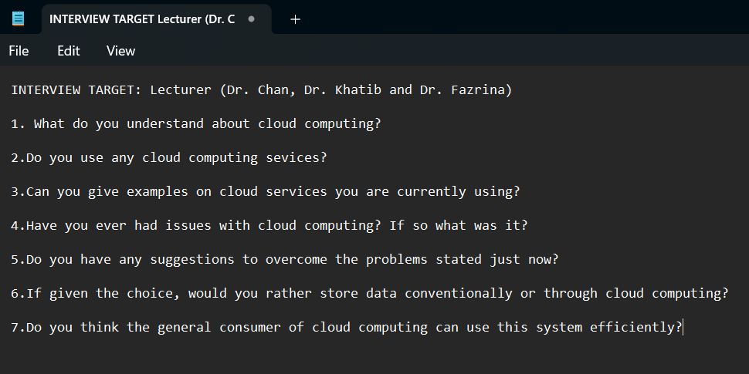

(*List of the Questions for the Interviewers*)

After that, we proceed to the phase to which is define, we list out all the problems after we do a discussion about the information that we obtained on the recent interview.

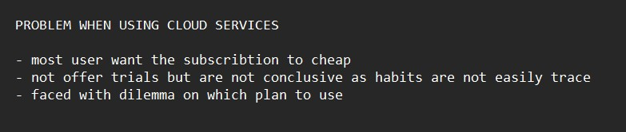

(*List of the problem from the user cloud computing*)

The next phase, ideate. We analyse and brainstorm our ideas to come up with the best solution as well as logical. After all the discussion we come up with the new planning based on the user habit or activity. Therefore, we will introduce our own cloud services, UCloud.

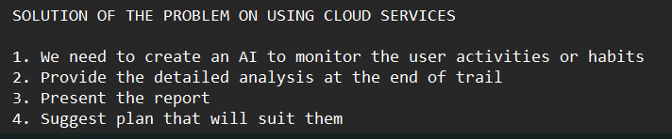

(*List of the solution after our brainstorming*)

In phase 4, we decided to create a mockup just using paper and cardboard. The cardboard will present as a device and paper will present as a sequence on how our cloud services, uCloud actually work. Lastly, in the prototype test, we will show how our cloud service works step by step.

As evidence, we will show a short video on the whole process of our group project of design thinking. We took some footage throughout the process of design thinking from empathy to prototype tests. This video needs to be credited to Naim, Mukritz and Adib Who create such a simple and creative video. Adib is the one who edited the whole video.

[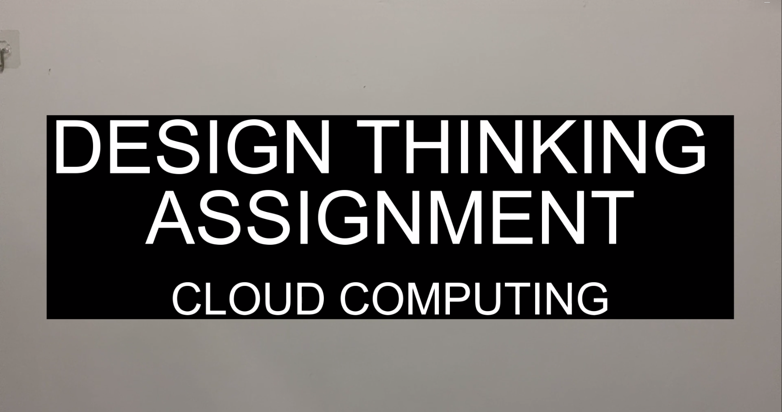](https://youtu.be/CE6Zk46dy7M?si=a0skmZJmTwwck6Iu)

# **REFLECTIONS**

I. Iman Abadi

1. What is your goal/dream with regard to your course/program?

I dream that I will be able to master all of the courses this program has to offer. Then hoping that I can apply this knowledge into building my career in the future. I also hope that this course will help shape me into a graduate with qualities that are sought after by companies that will contribute to my career.

1. How does this design thinking impact on your goal/dream with regard to

your program?

The design thinking has helped me to be better at problem solver. Each design thinking phase I went through has contributed critical values that can help me in the future. For example, the empathy phase has helped me to become better at communication by being more understanding of an individual’s point of view. Furthermore, the ideate phase has helped me by encouraging me to brainstorm ideas going for quantity over quality and choosing the best solution later. This has helped me to become better at critical thinking.

1. What is the action/improvement/plan necessary for you to improve your

potential in the industry?

To improve my potential in the industry, my plan is to start self-learning more often. In a world where technology is rapidly advancing, it is important to keep updated with current technologies because you cannot know everything. Thus, self-learning helps improve my potential in the industry because this shows that I am determined to learn, to keep innovating and having the perseverance to face all the challenges that come later on.

II. Muhammad Naim Bin Abdullah

1. What is your goal/dream with regard to your course/program?

* I want to be able to innovate something that will benefit society.
* Because of the 2U2I programmed in this course, I can insure my career.
* I hope to become proficient in SQL and programming techniques.

1. How does this design thinking impact on your goal/dream with regard to

your program?

* My understanding of the workings of the IT industry has expanded greatly as a result of the interview.
* I've learned time management skills to ensure that I turn in the assignment by the deadline.
* My ability to think critically has greatly improved because we must implement certain existing systems.

1. What is the action/improvement/plan necessary for you to improve your

potential in the industry?

* Hone my ability to "think outside the box" in my brain.
* I will put in more effort to complete my assignment flawlessly.
* I'm going to enhance my soft skills.
* I will effectively manage my time.

III. Muhammad Mukhritz Al Iman

# What is your goal/dream with regard to your course/program?

* We hope we can invent the new technologies to make humanity life easier
* I hope that I can learn programming
* I hope I can landed a good job after finish my course

1. How does this design thinking impact on your goal/dream with regard to your program?

* We think that this whole process should be used more often to learn something new as well as create a new invention.
* I think this help me to accept learn from my mistake
* this design thinking teach me to never easily give up
* This whole process help me to have a good communication with my teammates

1. What is the action/improvement/plan necessary for you to improve your potential in the industry?

* Improve our brain to “think outside the box” mindset.
* improve my communication skill
* improve myself to work harder
* create a lot more invention or idea to be share with everyone

IV. Ahmad Adib Zikri

# What is your goal/dream with regard to your course/program?

* We hope we can invent the new technologies to make humanity life easier
* I hope to get rich
* I hope to achieve something that my parents want

1. How does this design thinking impact on your goal/dream with regard to your program?

* We think that this whole process should be used more often to learn something new as well as create a new invention.
* I more knowing about the industry by obtain the knowledge from industry visit
* I more capable to make a video
* I gain more knowledge on how to interview someone

1. What is the action/improvement/plan necessary for you to improve your potential in the industry?

* Improve our brain to “think outside the box” mindset.
* Need more confident when talking
* Louder the voice when talking to someone
* Explore the video to know more about making a video

V. Muhammad Afiq Danial

# What is your goal/dream with regard to your course/program?

* I hope we can invent the new technologies to make humanity life easier
* I hope I can contribute more to the company
* I hope i can improve my analytical skills

1. How does this design thinking impact on your goal/dream with regard to your program?

* I think that this whole process should be used more often to learn something new as well as create a new invention.
* I think this process need to taught to every people who need a creative solving skills
* This process can make problem solving so much easier.

1. What is the action/improvement/plan necessary for you to improve your potential in the industry?

* Improve our brain to “think outside the box” mindset.
* Taking notes more often.
* Focus on lectures.
* Always eager to learn something new.

# **TASK DISTRIBUTION**

1. Ahmad Adib Zikri

* Interviewing
* Video Editing

1. Iman Abadi

* Gather the information
* Writing the report

1. Muhammad Naim

* Create a prototype
* Filming
* Gather the information

1. Muhammad Mukhritz Al Iman

* Interviewing
* Create a prototype
* Model of the video

1. Muhammad Afiq Danial

* Writing the report
* Filming